**SEMESTER TWO 2017**

**YEAR 12, Units 3 & 4**

**MATHEMATICS METHODS**

**Section One – Booklet 1**

**(Calculator–free)**

**Name: _________________________________**

|  |  |  |  |
| --- | --- | --- | --- |
| **MAW** | **VMU** | **MPC** | **AGC** |

**Circle your Teacher:**

**TIME ALLOWED FOR THIS SECTION**

Reading time before commencing work: five minutes

Working time for section: fifty minutes

**MATERIAL REQUIRED / RECOMMENDED FOR THIS SECTION**

**To be provided by the candidate**

Standard items*:* pens, pencils, pencil sharpener, highlighter, eraser, ruler.

**IMPORTANT NOTE TO CANDIDATES**

No other items may be taken into the examination room. It is **your** responsibility to ensure

that you do not have any unauthorised material. If you have any unauthorised material with you, hand it to the supervisor **before** reading any further.

**To be provided by the supervisor**

Question/answer booklet for Section One.

Formula sheet which may also be used for Section Two.

**Structure of this examination**

|  |  |  |  |  |  |
| --- | --- | --- | --- | --- | --- |
|  | Number of questions available | Number of questions to be answered | Working time (minutes) | Marks available | Percentage of exam |
| **Section One**  **Calculator—free** | **9** | **9** | **50** | **50** | **35** |
| Section Two  Calculator—assumed | 12 | 12 | 100 | 86 | 65 |
| Total marks | | | | 136 |  |

**Instructions to candidates**

1. The rules for the conduct of the Western Australian external examinations are detailed in the *Year 12 Information Handbook 2017.* Sitting this examination implies that you agree to abide by these rules.

2. Write your answers in the Question/Answer booklet.

3. You must be careful to confine your answers to the specific questions asked and to

follow any instructions that are specific to a particular question.

4. Spare pages are provided at the end of this booklet. If you need to use them, indicate

in the original answer space where the answer is continued i.e. give the page number.

5. Show all your working clearly. Your working should be in sufficient detail to allow your

answers to be checked readily and for marks to be awarded for reasoning. Incorrect

answers given without supporting reasoning cannot be allocated any marks. For any

question or part question worth more than two marks, valid working or justification is

required to receive full marks. If you repeat an answer to any question, ensure that you

cancel the answer you do not wish to have marked.

6. It is recommended that you **do not use pencil**, except in diagrams.

7. The Formula Sheet is **not** to be handed in with your Question/Answer booklet.

**This page has intentionally been left blank.**

**Question 1 (3+3+2+2 = 10 marks)**

Differentiate, simplifying and leaving your answers with positive indices where appropriate:

a) 

b) 

**Question 1 continued**

c) 

d) 

**Question 2 (3+3 = 6 marks)**

Use calculus to determine the following indefinite integral.

a) 

Use Calculus to determine the exact value of each of the following.

b) 

**Question 3 (2+3 = 5 marks)**

a) Determine 

b) Hence or otherwise, calculate the exact value of 

**Question 4 (4+2 = 6 marks)**

The discrete random variable *X* represents the outcome on a spinner. The probability distribution of *X* is displayed in the table below.

|  |  |  |  |  |  |
| --- | --- | --- | --- | --- | --- |
| *x* | 0 | 1 | 2 | 3 | 4 |
| *P(X=x)* | 2*n* | *n* | *m* | *m* | 0.1 |

a) Given that E(*X*) = 2 determine the values of *m* and *n*.

b) E() = 5.6 determine the value for Var(Z), where Z

**Question 5 (2+3 = 5 marks)**

Given that the and the , express each of the following in terms of *p* and *k*.

a) 

b) 

**Question 6 (4+3 = 7 marks)**

a) Solve , giving **exact answer(s)**.

b) Express *y* in terms of *x* if  , simplify your answer.

**Question 7 (2 marks)**

Determine the equation of the graph shown below.

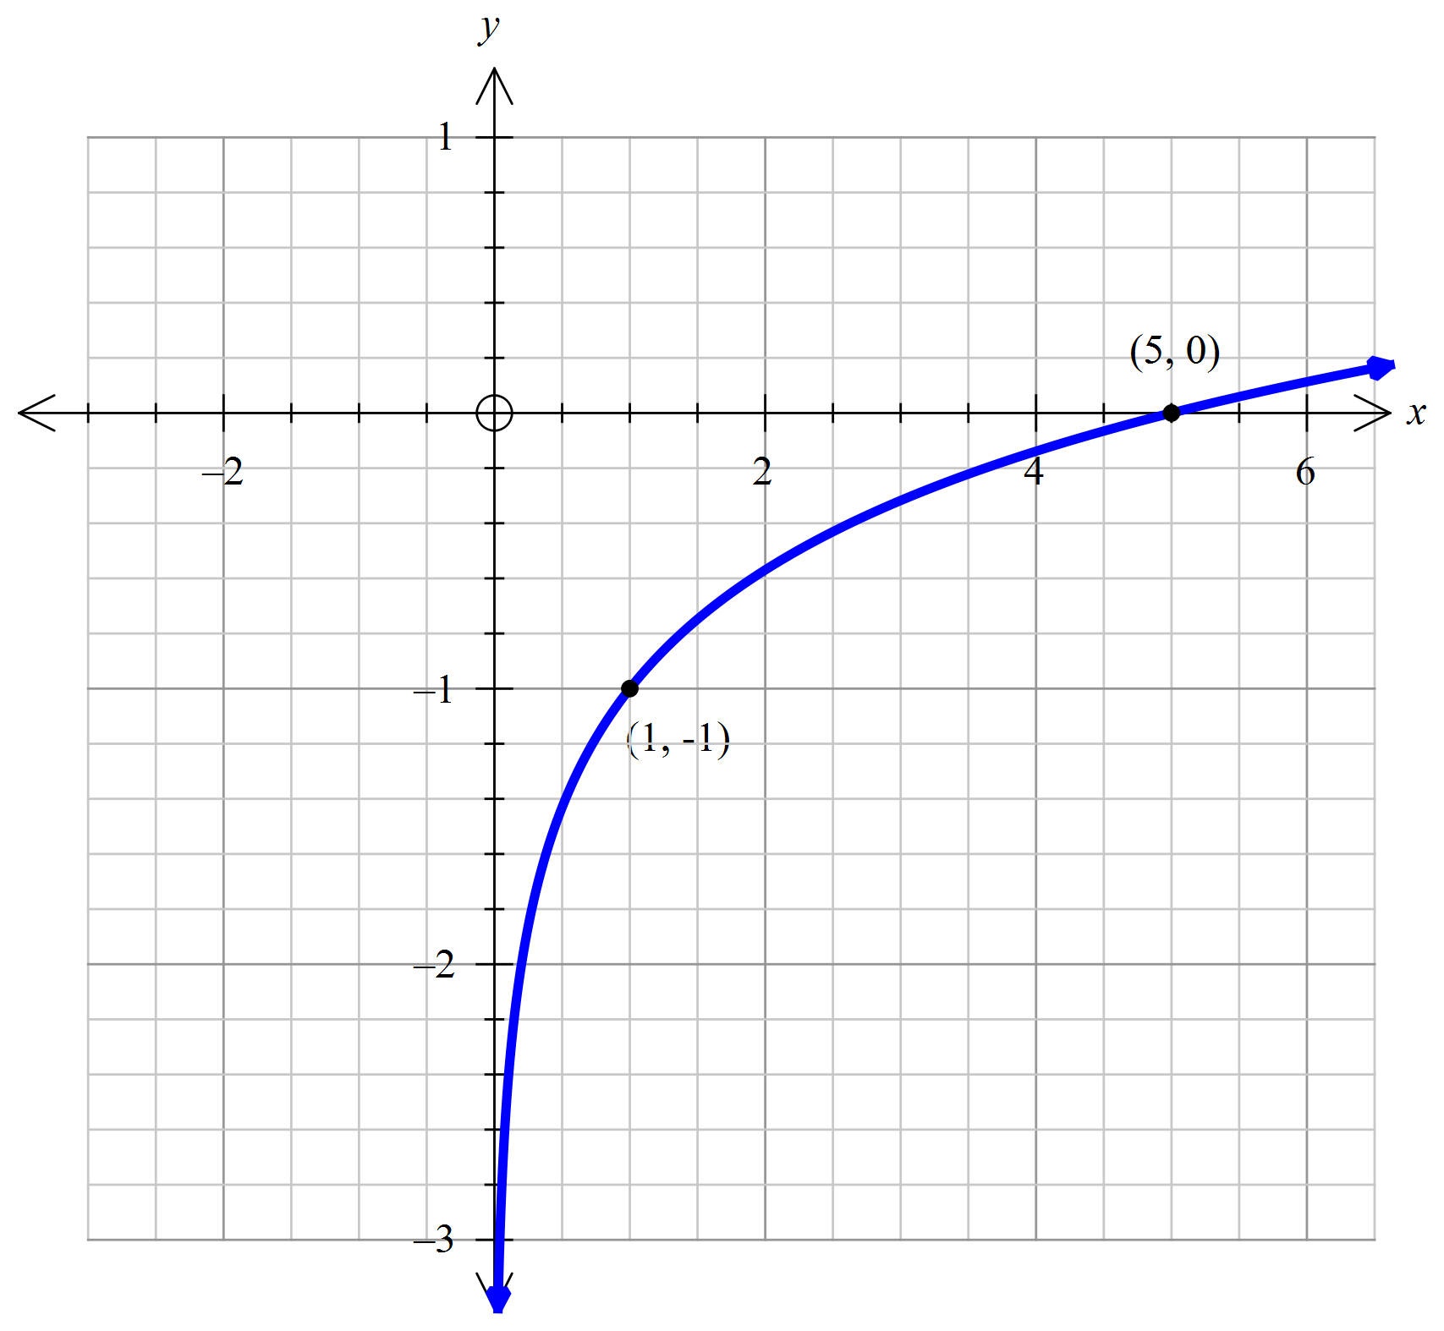

**Question 8 (3 marks)**

Determine the exact value of the *x*-intercept for the function defined by 

**Question 9 (6 marks)**

A random variable *X* has a mean of  and a probability density function:

 for  , determine the values of *k* and *a*.

**End of Questions for Booklet One**

Spare Working Page

Spare Working Page

Spare Working Page